SEC : A LAB 01 – WORKING WITH REGULAR FILES BATCH : A3

REG: 190905513 CSE 3163 NAME: MOHAMMAD DANISH EQBAL

LAB EXERCISES:

1. Write a program to print the lines of a file that contain a word given as the program argument (a simple version of grep UNIX utility)

Program:

#include <stdio.h>
#include <unistd.h>
#include <sys/stat.h>
#include <fcntl.h>
#include <stdlib.h>
#include <string.h>
int main(int argc, char *argv[])
{
int file, i = 0, j = 0;
char s[100], c;
if(argc != 3)
{
printf("Insufficient arguments\n");
exit(1);
}
if((file = open(argv[2], O_RDONLY)) == -1)
{
printf("No such file found...\n");
exit(1);
}
while((read(file, &c, 1)) > 0)
{
if(c != '\n')
{
s[i] = c;
i++;
}
else
{
j++;
s[i] = '\0';
i = 0;
if(strstr(s, argv[1]) != NULL)
printf("Line:%d '%s' \n", j, s);
}
}
exit(0);
}

Output:

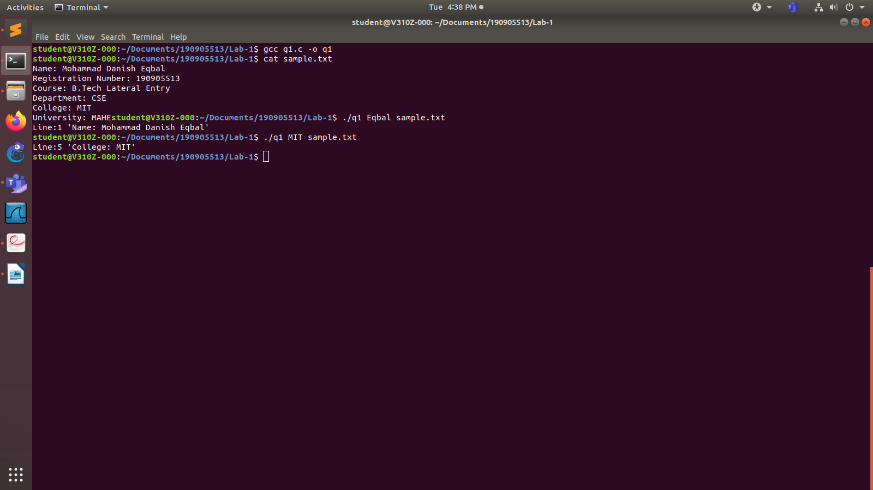
2. Write a program to list the files given as arguments, stopping every 20 lines until a key is hit. (a simple version of more UNIX utility)

Program:

#include <stdio.h>
#include <unistd.h>
#include <sys/stat.h>
#include <fcntl.h>
#include <stdlib.h>
#include <string.h>
int main(int argc, char *argv[])
{ int sfd, sfd2, i = 0, j = 0, k = 0;
char s[100], s2[100], c;
if(argc != 3)
{ printf("Insufficient arguments\n");
exit(1);
}
if((sfd = open(argv[1], O_RDONLY)) == -1)
{ printf("No such file found...\n");
exit(1);
}
while((read(sfd,&c,1)) > 0)
{ if(c != '\n')
{ s[i] = c;
i++;
}
else
{ j++;
k++;
s[i] = '\0';
i = 0;
printf("Line: %d \t %s \n", k, s);
if(j == 20)
{
fgetc(stdin);
j = 0;
}
}
}
close(sfd);
if((sfd2 = open(argv[2], O_RDONLY)) == -1)
{
printf("No such file found...\n");
exit(1);
}
k = 0;
while((read(sfd, &c, 1))>0)
{ if(c != '\n')
{
s2[i] = c;
i++;
}
else
{ j++;
k++;
s[i] = '\0';
i = 0;
printf("Line: %d \t %s \n", k, s2);
if(j == 20)
{ fgetc(stdin);
j = 0;
}
}
}
exit(0);
}

Output:

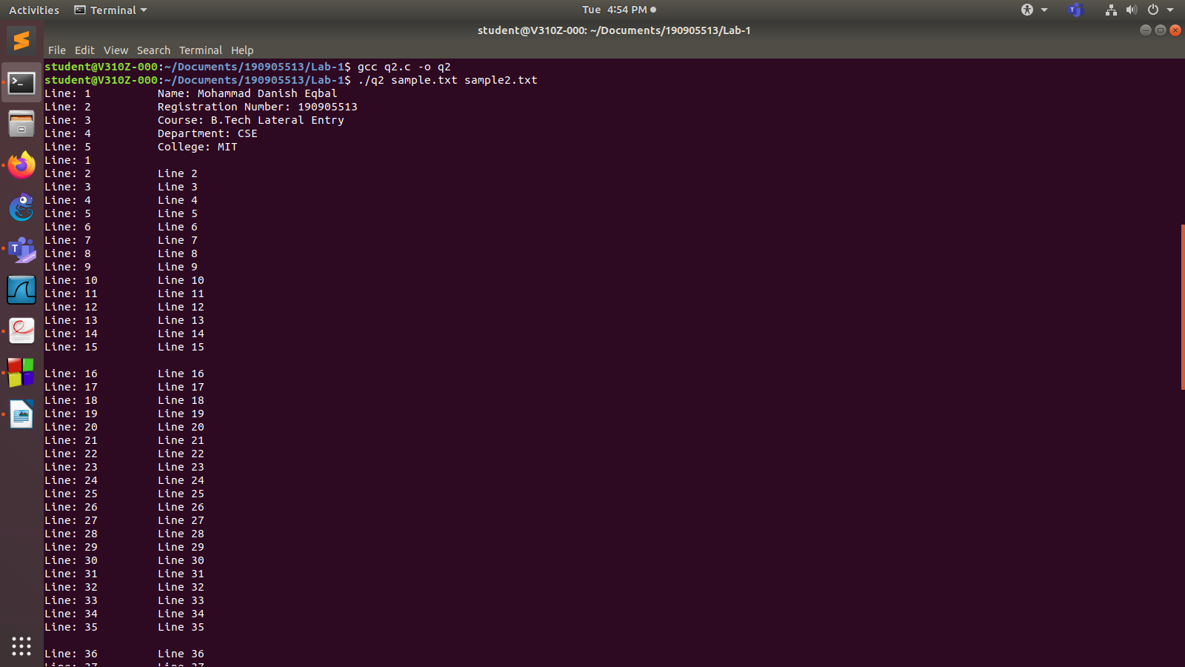

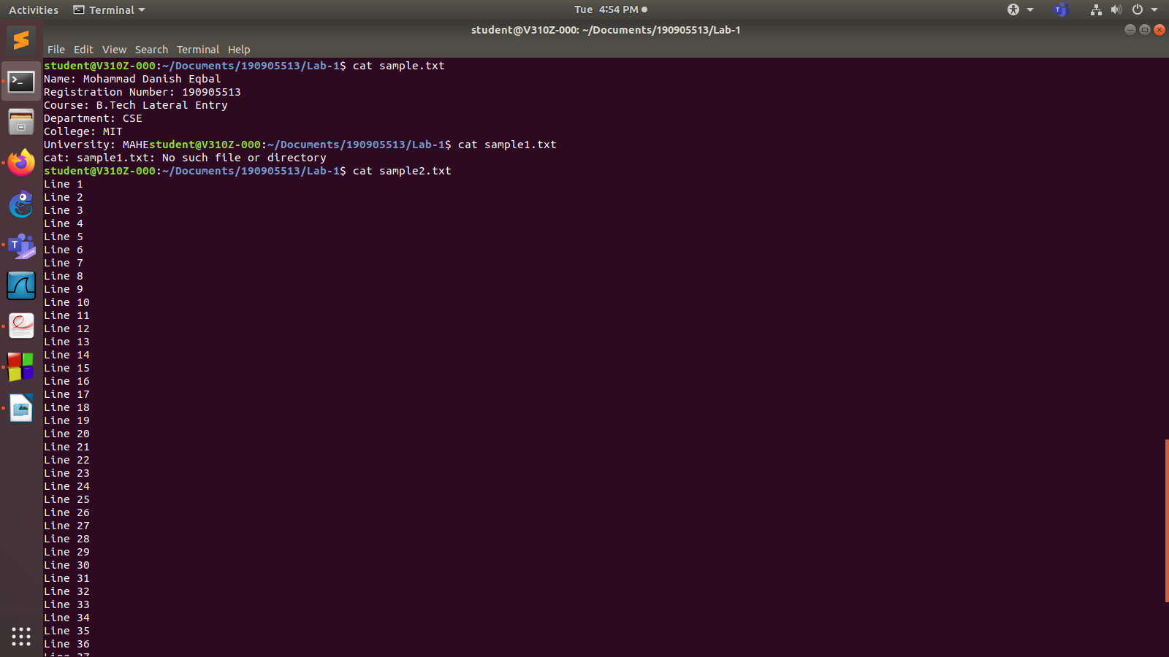

3. Demonstrate the use of different conversion specifiers and resulting output to allow the items to be printed.

Program:

#include<stdio.h>
#include<stdlib.h>
#include<errno.h>
int main()
{
int x = 500;
float y = 3.14;
char z = 'D';
char str[] = "MDE String";
printf(" x = %d\n y = %f\n z = %c\n str = %s\n hex. for x = %x\n", x, y, z, s, x);
errno = EPERM;
printf(" Error Access Errno: %m\n");
}

Output:

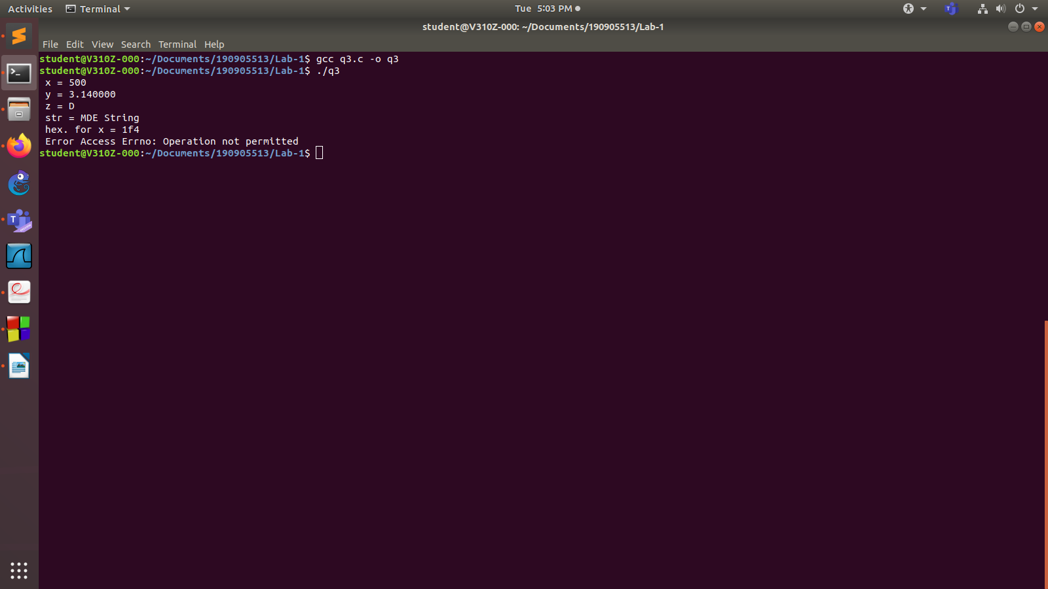
4. Write a program to copy character-by character copy is accomplished using calls to the functions referenced in stdio.h.
Program:
#include<stdio.h>
#include <unistd.h>
#include<sys/stat.h>
#include<fcntl.h>
#include<stdlib.h>
int main(int argc, char *argv[])
{
char c;
int input, output;
if(argc != 3)
{
printf("Insufficient arguments\n");
exit(1);
}
input = open(argv[1], O_RDWR);
output = open(argv[2], O_WRONLY|O_CREAT, S_IRUSR|S_IWUSR);
if(input == -1 || output == -1)
{
printf("No such file exists...\n");
exit(1);
}
while(read(input, &c, 1) == 1)
write(output, &c, 1);
printf("Copied Successfully...\n");
exit(0);
}

Output:
